Given an input text file that has some Ethernet packets, create a packet analyzer that does the following
- Read the file into some packets. Each line in the input file represents one packet data.
- Parse each packet into its own fields.
- Write the parsed packets with their fields in an output text file.
Notes:
- Sample input and output text file are given for reference.
- All packets are Ethernet packets, but they can either be just raw Ethernet frames or Enhanced Common Public Radio Interface (e-CPRI) frames built over Ethernet.
  - Ethernet packet is constructed as per the following figure:
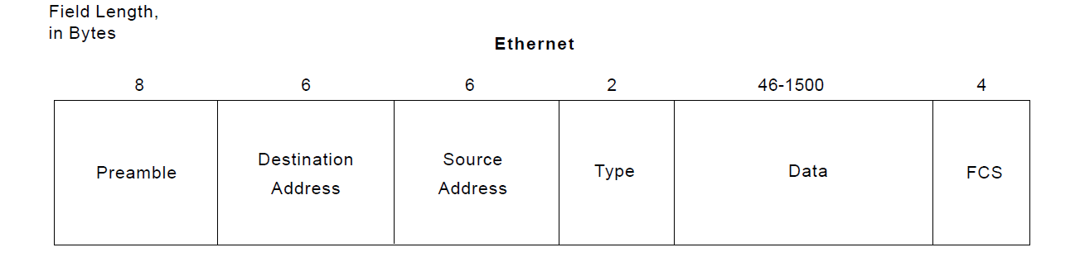
  - To know whether a frame is an e-CPRI frame, check that the Type field is “AEFE”.
  - Given e-CPRI frames are built over Ethernet, so it has the same fields as the Ethernet frame, but the payload/data field has the following:
    - Common Header:
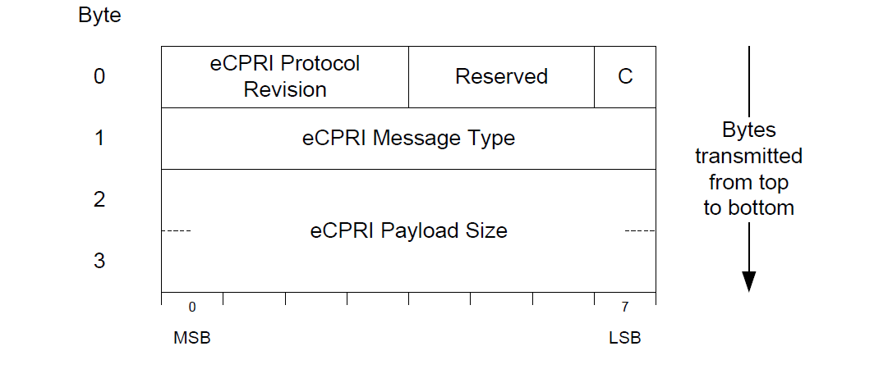

    - Real-Time Control Data:
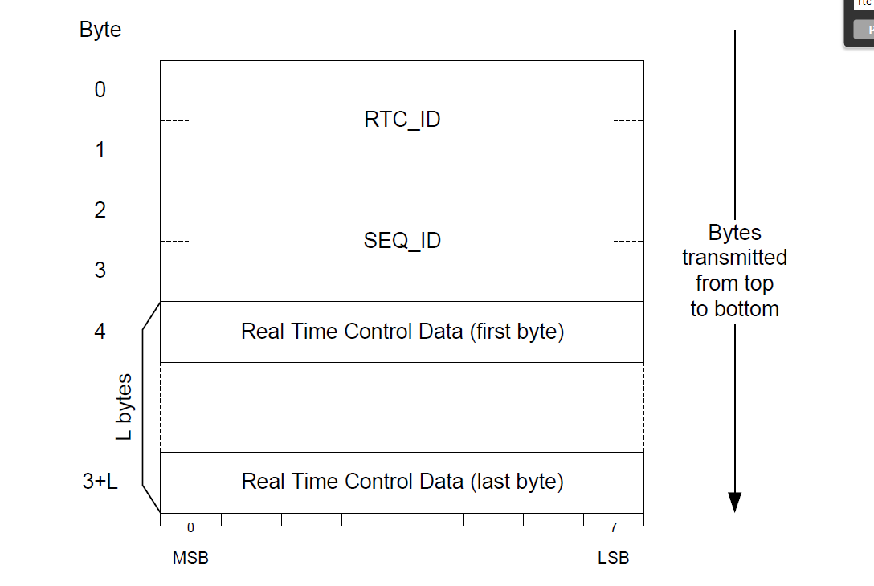
References:
- More Info on Ethernet frames:
  - https://en.wikipedia.org/wiki/Ethernet_frame
- e-CPRI Specifications:
  - http://www.cpri.info/downloads/eCPRI_v_2.0_2019_05_10c.pdf

